HEALTH AI

INTELLIGENT HEALTHCARE ASSISTANT

TEAM LEADER : GAYATHRI G
TEAM MEMBERS : 1. SRIMATHI S
2. ARIVUSELVI A
3. BHUVANESWARI P
4. PUNITHAVATHI K

1.INTRODUCTION
Artificial intelligence (AI) in healthcare involves using machine learning and other cognitive technologies to mimic human intellect, vast patient data for improved diagnosis and personalized treatment, and automate administrative tasks to streamline operations and reduce costs. Key applications include enhancing medical imaging analysis, conducting predictive analytics to identify at-risk patients, powering surgical robots, and providing accessible support through AI-driven chatbots for mental health. AI's ultimate goal is to improve patient outcomes, enhance the patient and caregiver experience, and create a more efficient and cost-effective healthcare system by balancing human expertise with technological capabilities.

2.PROJECT OVERVIEW
An Artificial Intelligence (AI) in Health care project aims to leverage machine learning and other AI technologies to improve patient diagnosis, treatment, and management, enhance operational efficiency, and reduce healthcare costs. These projects involve large medical datasets to detect patterns, predict outcomes, automate administrative tasks, develop personalized treatment plans, accelerate drug discovery, and provide virtual health assistance. Key components include advanced algorithms for medical image analysis, predictive models for disease risk, and AI-powered tools for remote patient monitoring, all while addressing critical challenges like data privacy, bias, and regulatory frameworks.

Features
Key Features of AI in Healthcare
- Enhanced Diagnostics and Prediction:
  - Medical Image Analysis: AI algorithms can medical images (X-rays, CT scans, etc.) with high accuracy, leading to earlier and more precise disease detection, such as cancer.
  - Predictive Analytics: AI systems patient data, including genetic information and lifestyle factors, to predict potential health risks and disease outbreaks, enabling proactive and preventive care.
- Personalized Medicine and Treatment:
  - Tailored Treatment Plans: By individual patient data, AI can create personalized treatment plans that are more effective and targeted.
  - Drug Discovery: AI accelerates the complex process of drug development and reduces the cost of clinical trials by patterns and predicting outcomes.
- Improved Patient Care & Engagement:
  - Virtual Health Assistants: AI-powered chatbots provide virtual health support, answer questions, offer health tips, and send appointment reminders.
  - Enhanced Compliance: AI tools can track and improve patient adherence to treatment plans and promote better engagement with their health.
- Streamlined Operations & Efficiency:
  - Automated Administrative Tasks: AI automates routine tasks like scheduling, billing, and managing electronic health records, reducing administrative workload for healthcare professionals.
  - Optimized Resource Allocation: Predictivehelps forecast patient admissions, allowing for the efficient allocation of hospital beds, staff, and equipment.
- Research and Population Health:
  - Data Analysis: AI canvast amounts of medical data to identify trends, monitor public health, and track the spread of infectious diseases.

3.ARCHITECTURE
AI in healthcare architecture integrates data analysis to design efficient, patient hospitals, leveraging tools for layout optimization, workflow, and resource management, while also encompassing the underlying hardware/software architecture like Armv9 and advanced AI models such as neuro-symbolic strategies to process vast amounts of medical data for improved patient outcomes.
Architectural Design & Planning
- Generative Design Tools:
AI assists architects by generating design options for healthcare facilities, optimizing space utilization, operational flow, and cost-effectiveness.
- BIM Integration:
AI-driven Building Information Model (BIM) enhances collaborative design processes, crucial for the complexity of healthcare facilities, by optimizing layouts and improving efficiency.
- Data-Driven Decisions:
Architects use AI to data and guide design decisions, such as optimizingthe placement of natural light to promote patient recovery and comfort.
- Predictive Analytics:
AI algorithms help predict patient demand and resource needs, informing the design of more efficient and adaptive healthcare spaces.
Underlying AI & System Architecture
- Hardware Architecture:
Architectures like Armv9 are designed to deliver enhanced AI performance and security in healthcare, enabling faster, more accurate disease detection and robust data protection.
- Neuro-Symbolic Models:
These models combine symbolic and sub-symbolic approaches to process large datasets, leading to innovative and optimal architectural designs for complex hospital needs.
- Data Integration:
A unified digital infrastructure connecting clinics, hospitals, social care services, patients, and caregivers via sensors and ambient intelligence is a long-term goal, requiring robust AI architecture for integration.
Impact on Patient Care & Operations
- Personalized Medicine:
AI vast medical data (genetics, lifestyle) to help create personalized treatment programs.
- Improved Diagnosis:
AI algorithms medical images like X-rays and CT scans to improve diagnostic accuracy and speed up disease detection.
- Enhanced Patient Flow:
AI optimizes patient flow and scheduling in hospitals, leading to reduced waiting times and an improved patient experience.

4.SET OF INSTRUCTIONS
1. GRADIO Framework Knowledge: GRADIO Documentation 2. IBM Granite Models (Hugging Face): IBM Granite models 3. Python Programming Proficiency: Python Documentation 4. Version Control with Git: Git Documentation 5. Google Collab’s T4 GPU Knowledge: Google collab.

5.RUNNING THE APLICATION
AI's AI for Medicine Specialisation provides practical experience in applying machine learning to concrete problems in medicine, such as predicting patient survival rates, estimating treatment plan efficacy, and diagnosing diseases from 3D MRI brain scans.

6.AUTHENTICATION
To access digital health portals, patients must use AI-driven multi-factor authentication. This method ensures a good balance between increased security, ease of use and convenience. In addition, AI-driven authentication can be used to protect patient data in hospital databases and prevent data breaches.

7.USER INTERFACE
Artificial intelligence (AI) is making big moves in every industry, including healthcare. Think of chatbots' handling triage, machine-learning (ML) algorithms' spotting early signs of disease, and easy-to-use systems that help doctors make faster data-driven decisions.

8.TESTING
Testing artificial intelligence (AI) in healthcare is a crucial, multi-faceted process that verifies AI system performance, safety, and efficacy through various methods, including clinical trials, regulatory compliance, and performance evaluations across diverse KPIs. It involves Health Technology Assessment (HTA), data quality checks, bias detection, and safety validation to ensure responsible integration into clinical practice, ultimately ensuring patient safety and accurate results.
Key Aspects of AI Testing in Healthcare
- Performance and Diagnostic Accuracy:
AI algorithms must be rigorously tested to ensure high diagnostic accuracy and sensitivity, especially in medical imaging, where their performance is compared against radiologists.
- Data Quality and Integrity:
AI systems rely heavily on high-quality data; therefore, testing must include validation of data inputs to prevent errors and bias.
- Bias Detection:
AI systems are susceptible to bias present in training data, necessitating testing to identify and mitigate biases that could lead to unfair or inaccurate outcomes for certain patient groups.

- Safety and Validation:
Ensuring the safety of AI in healthcare involves human-AI collaboration, safety validation, and robust protocols to prevent harm to patients.
- Clinical Validation:
This involves testing AI solutions in real-world clinical settings to assess their actual impact on patient care and clinical decision-making.
- Regulatory Compliance:
AI-powered software needs to comply with stringent regulations, such as those from the FDA, which require documented processes and adherence to standards for medical devices.
- Ethical Frameworks:
Robust ethical and legal frameworks guide the testing process to ensure the responsible and effective integration of AI.
Key Performance Indicators (KPIs)
- User KPIs : Measure user engagement and the overall user experience with the AI system.
- Diagnostic Task KPIs: Assess the correctness and performance of the AI in diagnostic tasks.
- Image Quality KPIs: Evaluate image appearance characteristics relevant for AI algorithms that process images.
- Processing Performance KPIs: Summarize the technical capabilities and processing speeds of the AI system.
- Diagnostic Process KPIs: Determine the overall clinical return on investment of the AI tool.

9.SCREENSHOT
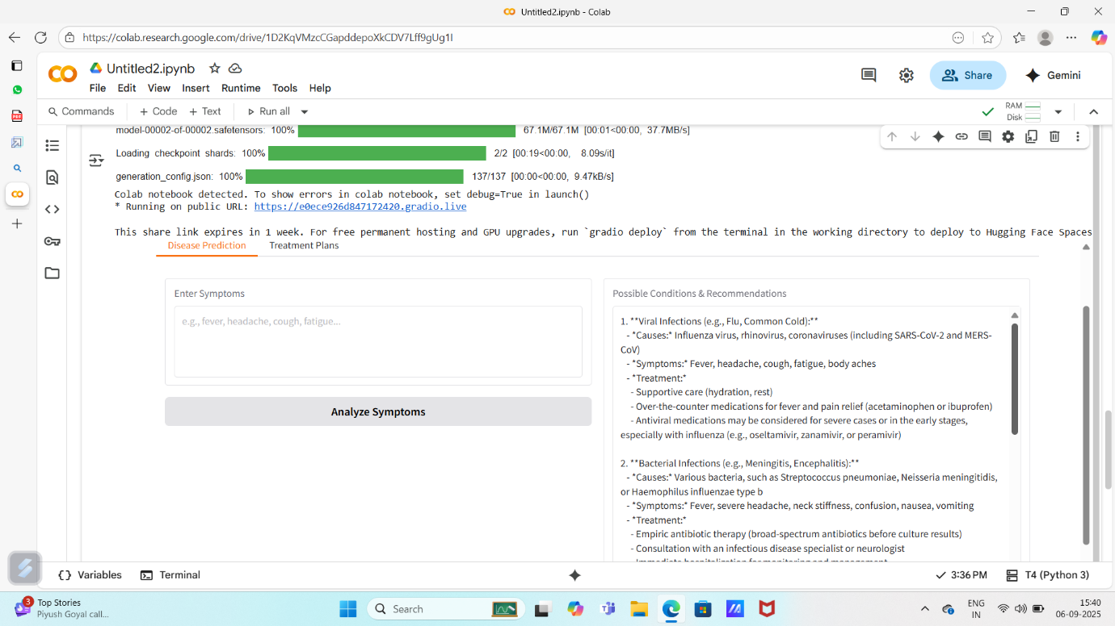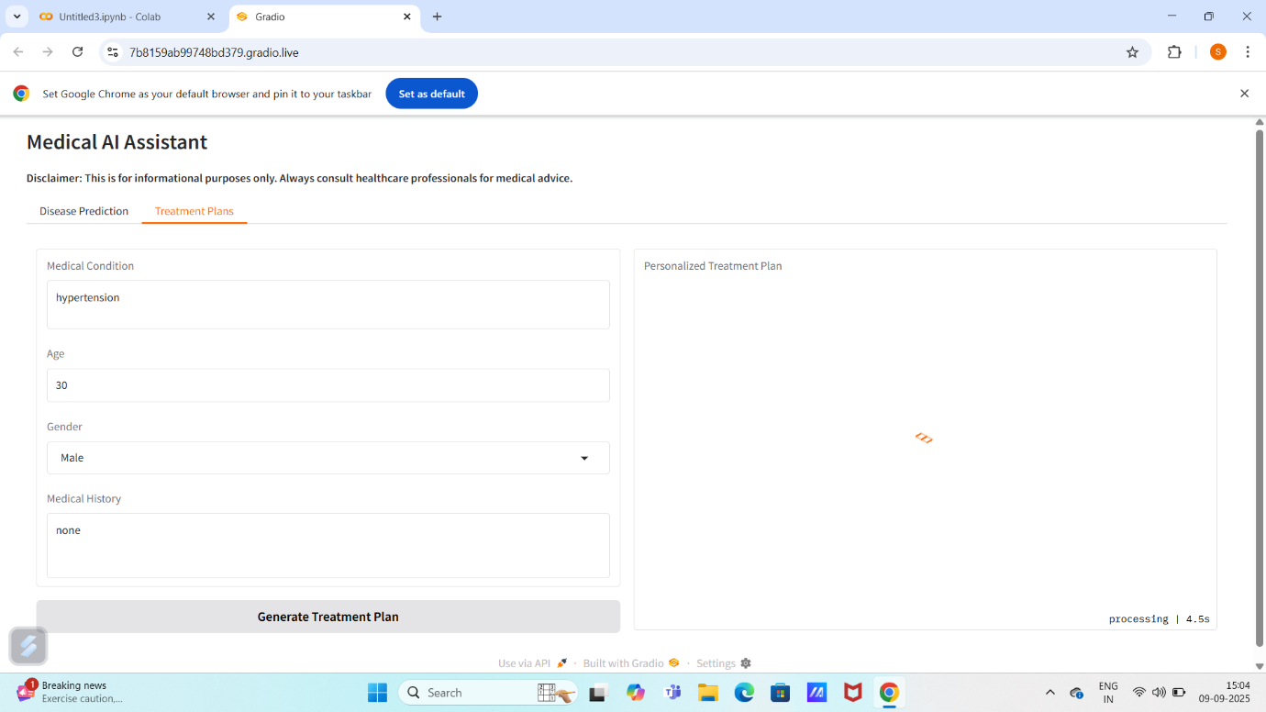

10.FUTURE ENHANCEMENT
Artificial intelligence (AI) is set to significantly enhance future healthcare through personalized treatment plans, earlier and more accurate diagnoses, improved drug discovery, and streamlined administrative tasks, ultimately leading to better patient outcomes and more efficient resource allocation. AI-driven tools like predictive analytics, robotic surgery, and virtual health assistants will transform patient care and hospital operations, though challenges related to data privacy, algorithmic bias, and the need for strong ethical frameworks must be addressed for responsible implementation.

11.CODING



CONCLUSION:
The project effectively demonstrates the potential of AI in revolutionizing healthcare assistance. By integrating IBM's Granite language model, the platform enables users to receive personalized health insights through Patient Chat, Disease Prediction, Treatment Plan Generation, and Health Analytics, making healthcare information more accessible.
Utilizing IBM Watson Machine Learning, the application ensures accurate health question answering, detailed disease prediction, personalized treatment recommendations, and insightful health trend analysis. The structured development process—spanning model selection, core feature implementation, backend and frontend development, and deployment—led to the creation of an interactive, user-friendly platform.
Built with facilitates seamless visualization of health data and AI-generated insights, ensuring an efficient and responsive experience. This project highlights how targeted AI models and a well-structured framework can enhance healthcare accessibility. With future scalability in mind has the potential to expand its capabilities, incorporating more advanced diagnostics and broader medical applications.

